
NAME:Areeba Khalid
ID: F2023065377
COURSE: SOFTWARE ENGINEERING
SECTION: W-4
Assignment : 2
PROJECT: Online Shopping System

Gantt Chart:

Use Case Diagram
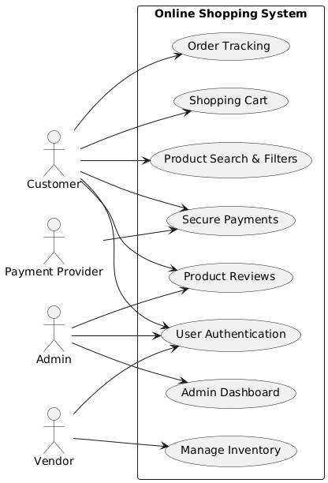

Activity Diagram

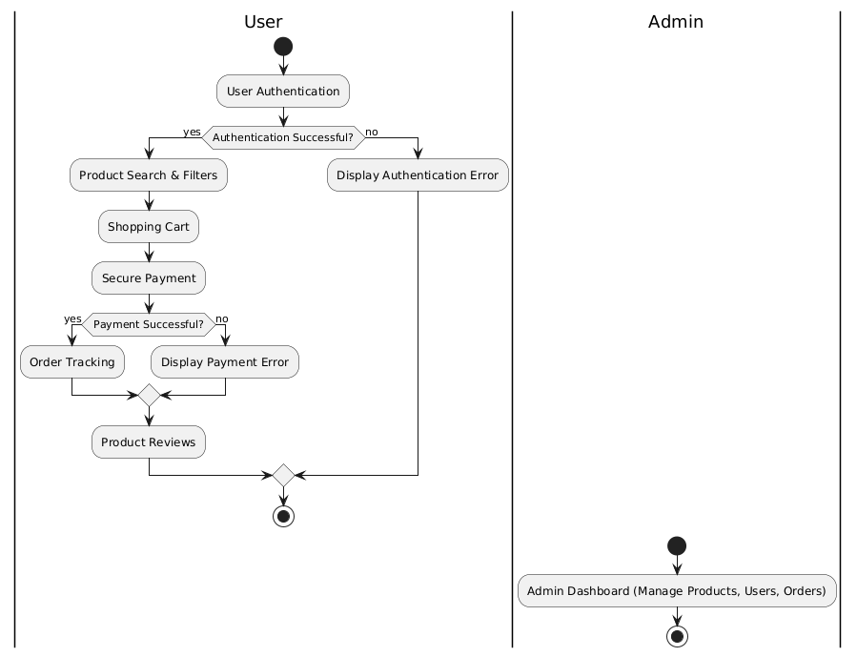
Class Diagram

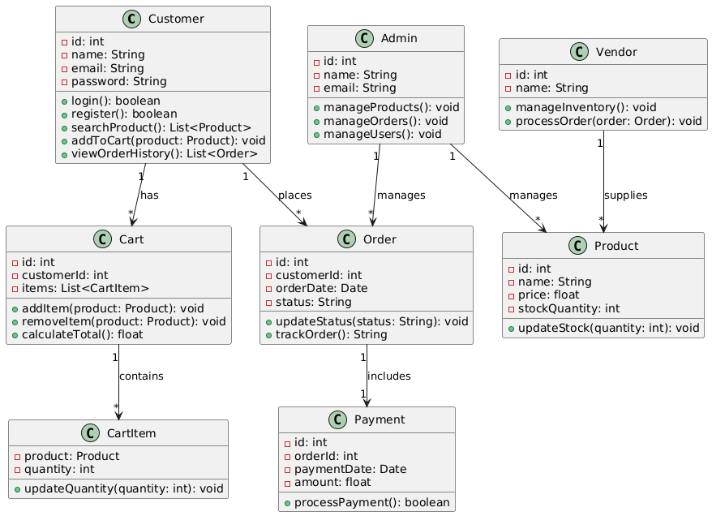

Sequence Diagram
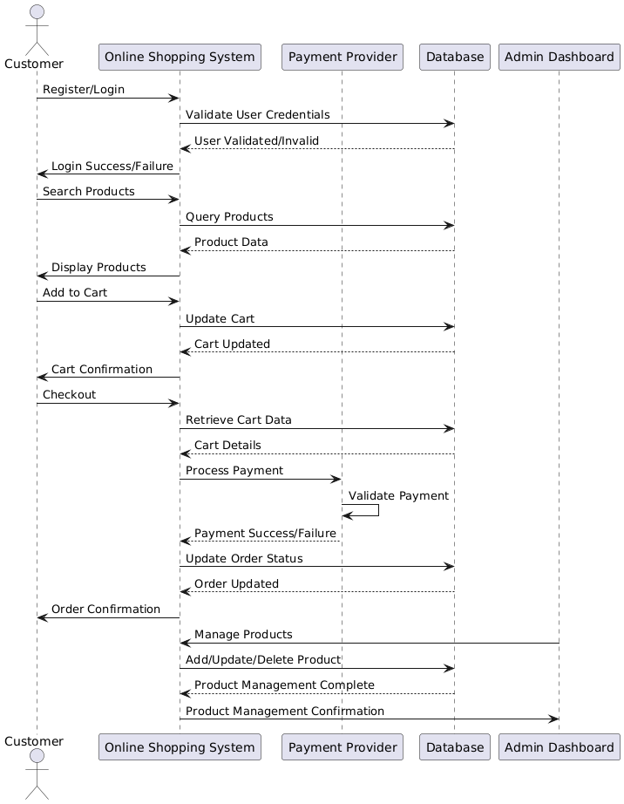

Architecture Diagram
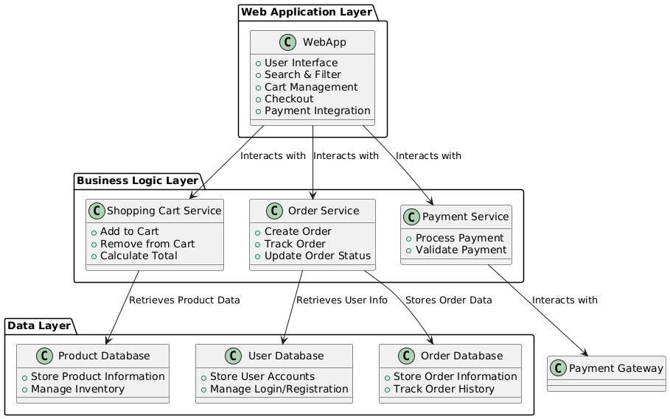

Entity Relation Diagram
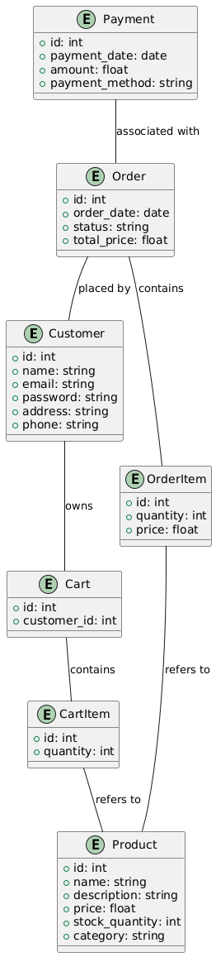
DFD Level 0
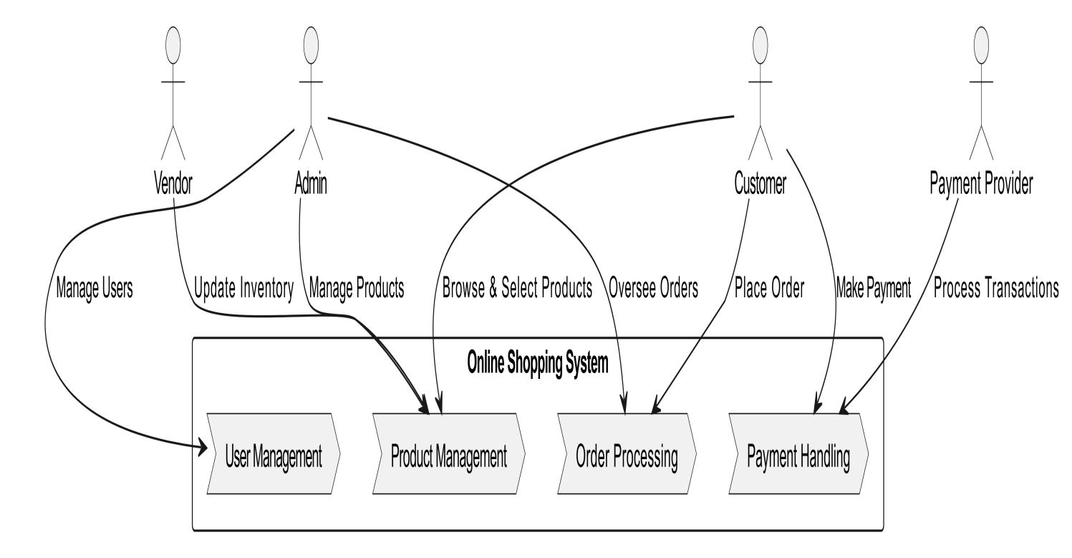

DFD Level 1
